

**UGANDA E-LEARNING INITIATIVE FOR EDUCATION INSTITUTIONS**

Date: 16/01/2025

Ref: 016/RFP/CSTS/25

Attention

Dear Sir/Madam,

|  |
| --- |
| **REF: REQUEST FOR PROPOSAL FOR THE SUPPLY OF ASSISTIVE DEVICES AND RELATED ACCESSORIES.**  **NOTICE:**  **Prospective proponents are expected to carefully examine this tender dossier and comply with all its instructions, forms, provisions and specifications. Failure to submit a proposal containing all the required information and documentation within the specified deadline will lead to the rejection of the proposal.** |
| **TITLE OF ASSIGNMENT** |
| Supply of devices and accessories. |
| **BACKGROUND** |
| Cyber School Technology Solutions (CSTS) is a global company offering online education systems, with experience designing and developing digital educational resources, portals and learning management systems. The one-stop-site for e-learning solutions, CSTS, works with experienced educators and technocrats across the globe in designing and developing these digital educational resources, portals and learning management systems. CSTS has worked for over 15 years in Uganda deploying its digitized version of the Uganda O-level curriculum in Sciences and Mathematics (Digital Science and Virtual Lab software) to over 1,000 secondary schools and educational institutions across Uganda.  In 2021, CSTS entered and partnered with Mastercard Foundation to implement a project called the ***Uganda e-Learning Initiative for Educational Institutions.*** The goal of the project is to improve access to quality and relevant education for 95,000 youth (50% women), in 20 Education Institutions (EIs), with 12,500 transitioning into meaningful and dignified work by 2026, with the anticipated impact on the education system of **having a responsive education and training system that prepares and transitions young people into meaningful and dignified work.** To achieve this goal, the project will be implemented in a phased manner starting with 6 higher institutions of learning and after two years the successful components are scaled to 14 more Higher Institutions of learning in the next 3 years.  This is to be done by:   1. Supporting Education Institutions (EI) to successfully implement eLearning, thus increasing their resilience against COVID-19 and future situations preventing in-class learning. 2. Addressing the skills mismatch between the young people graduating from EIs and employability by integrating work readiness and entrepreneurship skills into the technical skills curriculum.   This intervention will have two outcomes:   1. Increased access to market-responsive education and training systems through integration of work readiness and entrepreneurship skills. 2. Enhanced quality online education and skilling in Education Institutions (EIs).   The interventions to be implemented to achieve the above two outcomes are;   1. Development and adoption of work readiness and entrepreneurship skills. 2. Deployment of Online Learning and Management System (LMS) platform for participating Education Institutions. 3. Training of instructors in digital pedagogy and instructional design, content development, and online acquisition. 4. Increasing access to affordable internet and devices. 5. Supporting EIs in the development, adaptation, and implementation of eLearning policies. 6. Supporting the transitioning of youth into work through internships and work-study programs.   For successful implementation of these interventions with inclusion and safeguarding principles, it requires students with disabilities in the EIs to have assistive devices. As such, Cyber School Technology Solutions through this call, is seeking for the services of a supplier to supply the assistive devices and related accessories.   |  | | --- | | **OBJECTIVES** |   a) Procure **assistive devices** and accessories based on the technical specifications outlined in Appendix A;  b) Ensure that all devices are installed with the additional required software indicated in Appendix A  c) Ensure that all assistive devices are prepared, shipped and received at designated CSTS site(s)so as to facilitate the agreed configuration and distribution schedule.   |  | | --- | | **CONTRACT FOR DELIVERABLES** |   The selected proponent will be requested to enter into negotiations for an agreement with CSTS for the provision of the Deliverables. The term of the agreement will be based on the timeframes outlined in the successful bid proposal.   |  | | --- | | **NO GUARANTEE OF VOLUME OF WORK or EXCLUSIVITY OF CONTRACT** |   CSTS makes no guarantee of the value or volume of work to be assigned to the successful proponent. The Agreement to be negotiated with the selected proponent will not be an exclusive contract for the provision of the described Deliverables. CSTS may contract with others for the same or similar deliverables to those described in the RFP. |
| **DELIVERABLES & SCOPE** |
| **The Supply of assistive devices and accessories;**  **Scope:**  The supplier is expected to provide the following assistive devices and software solutions, along with associated services:  **Digital Hearing Aids:**   * Provide a variety of digital hearing aids suitable for individuals with varying degrees of hearing loss. * Include options for adjustable settings and noise reduction features. * Ensure compliance with relevant industry standards and regulatory certifications.   **Audio Recorders:**   * Supply high-quality audio recorders for individuals with visual or hearing impairments. * Devices must have high storage capacity, clear sound quality, and ease of use. * Recorders should support voice commands, playback options, and file transfer capabilities.   **Fusion Software:**   * Provide Fusion Software, compatible with relevant operating systems. * Include licenses for the required number of users. * Ensure the software integrates with existing assistive technologies and is accessible to users with visual or cognitive impairments.   **Focus Blue 40:**   * Supply Focus Blue 40 Braille display devices. * Ensure compatibility with both Windows and Mac operating systems. * Devices should include a full range of Braille characters and buttons, as well as wireless connectivity.   **Victor Readers:**   * Provide Victor Reader devices for accessible reading of books, documents, and media. * Devices must support multiple file formats and have simple navigation controls. * Ensure devices are lightweight, portable, and battery-efficient.   **Dragon Software (Speech Recognition):**   * Provide Dragon software for speech-to-text and dictation purposes. * Include licensing for the required number of users and ensure software is compatible with both Windows and Mac platforms. * Ensure accuracy of speech recognition and adaptability to individual user accents and speaking patterns.   **Deliverables**  The following deliverables are required as part of the contract:  **Provision of Devices and Software:**   * Timely delivery of all requested devices (hearing aids, audio recorders, Focus Blue 40, Victor readers) and software (Fusion and Dragon) in new, unused condition. * Provide any necessary accessories, such as charging stations, cables, or specialized cases, along with the main devices.   **Licenses and Subscriptions:**   * Supply all required licenses for software, ensuring compliance with relevant terms and conditions. * Include subscription or maintenance options for software updates and technical support.   **Installation and Setup:**   * Provide installation and configuration services for all devices and software as required. * Ensure compatibility with existing user systems and assistive technology tools.   **User Training and Support:**   * Deliver training sessions for end-users to ensure effective use of the devices and software. * Provide comprehensive user manuals and documentation for all devices and software. * Offer technical support and troubleshooting services for a specified period after delivery.   **Warranty and Maintenance:**   * Include warranty coverage for all devices and software, detailing repair and replacement policies. * Provide options for ongoing maintenance, upgrades, or service plans for the assistive devices and software.   **Compliance and Documentation:**   * Ensure all devices meet the required industry standards and certifications. |
| **ROLE OF IMPLEMENTING PARTNER** |
| The supplier is expected to work closely with staff of the implementing partner (CSTS). Specifically, the implementing partner (CSTS) staff will:     * Coordinate with the EIs to plan, and support the configuration, training and distribution of devices. * Report on the distribution of devices.   The supplier is expected to provide a high level of cooperation with the assigned staff to ensure quality deliverables of the assignment. Likewise, the implementing partner will support the supplier to ensure successful execution of the assignment. |
| **DURATION AND TIME FRAME** |
| The assignment is expected to begin on 11/02/2025 and be completed not later than 28/02/2025.  NB. If external conditions hamper the execution of the assignment, affecting the work plan, the supplier will agree with CSTS on ways to guarantee the accomplishment of the assignment. |
| **REPORTING** |
| The supplier will report to the Affordable Internet and Device Officer and/or to the Project Manager for overall strategic guidance and consult with the Affordable Internet and Device Officer for the day-to-day management and coordination of the assignment. |
| **FORMAT OF THE PROPOSAL** |
| The proposal should clearly indicate the following;   * Technical proposal detailing interpretation of the terms of reference (ToR), comments on the ToR if any, and why they are most suitable for the assignment (max 25 pages) * Detailed CVs of all engineers or personnel proposed to work on the assignment as well as their roles and responsibilities under the assignment. * Detailed work plan and timeline for the assignment * Report Structure * Financial proposal, quotations with detailed breakdown of tasks and costs stated in US Dollars. * Evidence of work experience including 3 recent accomplished assignments of similar focus and scope and respective contacts of reference |
| **QUESTIONS AND CLARIFICATIONS** |
| Tenderers may submit questions and clarifications by email until 31st January 2025, 5:00pm EAT to the following email contact: [procurement@cyberschooltech.co.ug](mailto:procurement@cyberschooltech.co.ug) with copy to [klubega@cyberschooltech.co.ug](mailto:klubega@cyberschooltech.co.ug), [dkisembo@cyberschooltech.co.ug](mailto:dkisembo@cyberschooltech.co.ug) and [jrmukiibi@cyberschooltech.co.ug](mailto:jrmukiibi@cyberschooltech.co.ug) . |
| **INSTRUCTIONS TO SUBMIT A TENDER** |
| **Response Format**  Tenders should be electronically submitted in PDF (for narrative) and excel (for the budget).  Hand-written tenders will not be accepted.  **Content of Tenders**  Tenderers must provide sufficient information in the proposals to demonstrate compliance  with the requirements set out in the Terms of Reference.  In addition, the tender shall include documents and information below – and in the below order:   1. Copy of company registration certificate 2. List of directors 3. Copy of Memorandum and Articles of Association 4. Address of the company or offices 5. Contact person (name, email, phone) 6. Copy of tax compliance certificate 7. TIN number & VAT number 8. NSSF Clearance certificate 9. Previous NDA Clearance certificate 10. Company profile 11. Bank details 12. Copy of latest company audited accounts 13. Valid Trading License 14. Three letters of reference from reputable clients 15. CVs for key staff for the assignment.   NB: Failure to provide the above and in the formats stipulated may result in the disqualification of the tender.  **Late tenders**  Late tenders shall not be accepted.  Cyber School Technology Solutions (CSTS) reserves the right in its sole discretion to clarify any tender after closing by seeking further information from any or all tenderers. However, tenderers are cautioned that any clarification sought will not be an opportunity to either correct or change their tender in any manner.  **Period of validity of tenders**  Tenderers shall be bound by their tenders for a period of thirty (60) days minimum from the  deadline for submission of their proposals.  **Currency of tenders**  Tenders will only be presented in US Dollars ($).  **Language of tenders and procedure**  The tenders, all correspondence and documents related to the tender must be written in English.  **Costs of preparing tenders**  All costs incurred by the tenderers in preparing and submitting the tender are not reimbursable.  All such costs will be borne by the tenderers.  **Tender process**  The contract will be awarded to the tender offering best value for money (i.e. the tender offering the best price-quality ratio) or, as appropriate, to the tender offering the lowest price. CSTS will evaluate the tenders received against objective criteria which enable measuring  the quality of the tenders and which take into account the price.  Tenders will be examined and evaluated by the Evaluation Committee appointed by CSTS. All tenders will be assessed according to the following steps and criteria:  **Opening and administrative checks:** Tenders will be assessed on whether the deadline was met, if any of the requested information is missing or incorrect, and if the supporting documents requested for submission have been fully provided.  If any of the requested information is missing or is incorrect, the tender may be rejected on that sole basis and not be evaluated further.  The tenders that pass this check will be evaluated in accordance with the Evaluation Grid as  presented below:  Cumulative Analysis;  The proposals will be evaluated using the cumulative analysis method with 70% technical and 30% financial scoring. The proposal with the highest cumulative scoring will be awarded the contract.  Applications will be evaluated technically, and points are attributed based on how well the proposal meets the requirements of the Terms of Reference using the guidelines detailed in the table below:  When using this weighted scoring method, the award of the contract may be made to the individual consultant whose offer has been evaluated and determined as:  a) Responsive/compliant/acceptable, and  b) Having received the highest score from a pre-determined set of weighted technical and financial criteria specific to the solicitation.  * Technical Criteria weighting. 70%  * Financial Criteria weighting. 30%  Only candidates obtaining a minimum of 50 points in the Technical Evaluation would be considered for the Financial Evaluation. Interviews may be conducted as part of the technical assessment for shortlisted proposals.  Technical Criteria – 70%   |  |  | | --- | --- | | **Criteria (Quality Score)** | **Scale** | | Understanding of the ToR | 1-5 | | Proof of ability to provide after sales services | 1-20 | | Sample Device | 1-5 | | Experience in supply of similar devices and related accessories | 1-20 | | Knowledge of gender equality, safeguarding and women empowerment issues (leadership) / livelihoods / GBV / social norms interventions | 1-10 | | Clear and realistic workplan including detailed delivery plan for the arrival of laptops to facilitate the delivery schedule | 1-10 |   Eventually, the price-quality ratio will be calculated by dividing the total quality score by  the price tendered.  Financial Criteria Weighting – 30%; Lowest Price  Any attempt by a bidder to influence the evaluation committee in the process of examination,  clarification, evaluation and comparison of tenders, to obtain information on how the procedure is progressing or to influence the decision concerning the award of the contract will result in the immediate rejection of the tender.    **Notification award and contract signature**  The tenderers will be informed in writing of CSTS’s decision concerning their tender  and, if rejected, the reasons for the negative decision.  Following the decision to award, the successful tenderer will be offered a contract based on CSTS’s standard service agreement. If the successful tenderer fails to sign and send back  the contract within five (05) working days, CSTS may consider the award  notification null and void.  **Cancellation of the tender procedure**  In the event of a cancellation of the tender procedure, tenderers will be notified by CSTS.  Cancellation may occur where and when:  1. The tender procedure has been unsuccessful in terms of quality and/or quantity (less than  3) of tenders received;  2. The economic or technical parameters of the project have been fundamentally altered;  3. Exceptional circumstances or force majeure render normal performance of the project  impossible;  4. All technically compliant tenders exceed the financial resources available;  5. There have been irregularities in the procedure, in particular where these have prevented  fair competition;  6. Eligibility criteria were not fulfilled and/or incomplete tender dossier submitted.  NB: Under no circumstances will CSTS be liable for damages or losses, whatever  their nature, in relation with the cancellation of the tender. The publication of a procurement  notice does not commit CSTS to implement the announced programme, project  or assignment.  **Ethics**  CSTS conducts its activities with the greatest respect for its stakeholders with the  aim of honoring the trust placed in it by donors and beneficiaries and achieving the goals it shares with them. It undertakes to foster and respect the rights of beneficiaries in accordance with the UN conventions (UN Convention on Human Rights, Convention on the Rights of the Child, Convention on the Elimination of All Forms of Discrimination against Women, and Convention on Racial Discrimination) and treaties and the principles of international law. Furthermore, CSTS undertakes to comply with the legal provisions, guidelines and policies of the donor (Mastercard Foundation).  CSTS takes particular care not to work with individuals or organizations involved in drug trafficking, human exploitation or people trafficking, fraud or tax evasion, or suspected of being associated with any other form of criminality or terrorism.  CSTS fosters a culture of trust and respect. It requires all employees and contractual  partners to conduct themselves correctly – everywhere and at all times.  **Insurance**  The tenderer shall bear sole responsibility for any losses or damages incurred and for personal  insurance cover (for social benefits, sickness, accident and repatriation) in relation to the tender process as well as during the execution of the assignment in case of the award of a contract.  **Proponents to Follow Instructions**  Proponents should structure their proposals in accordance with the instructions in the RFP. Where information is requested in the RFP, any response made in a proposal should reference the applicable section numbers of the RFP where that request was made.  **CSTS’s Information in RFP Only an Estimate**  CSTS and its advisers make no representation, warranty or guarantee as to the accuracy of the information contained in the RFP or issued by way of addenda. Any quantities shown or data contained in the RFP or provided by way of addenda are estimates only and are for the sole purpose of indicating to proponents the general size of the work. It is the proponent’s responsibility to avail itself of all the necessary information to prepare a proposal in response to the RFP.  **Communication after Issuance of RFP**  *Proponents to Review RFP*  Proponents shall promptly examine all of the documents comprising the RFP, and  (a) shall report any errors, omissions or ambiguities; and  (b) may direct questions or seek additional information in writing by email on or before the proponent’s Deadline for Questions to the CSTS Contact. All questions submitted by proponents by email to the CSTS Contact shall be deemed to be received once the email has entered into the CSTS Contact’s email inbox. No such communications are to be directed to anyone other than the CSTS Contact. CSTS is under no obligation to provide additional information.  It is the responsibility of the proponent to seek clarification from the CSTS Contact on any matter it considers to be unclear. CSTS shall not be responsible for any misunderstanding on the part of the proponent concerning the RFP or its process.  *All New Information to Proponents by Way of Addenda*  The RFP may be amended only by an addendum in accordance with this section. If CSTS, for any reason, determines that it is necessary to provide additional information relating to the RFP, such information will be communicated to all proponents by addenda.  Each addendum forms an integral part of the RFP. Such addenda may contain important information, including significant changes to the RFP. Proponents are responsible for obtaining all addenda issued by CSTS. Proponents should confirm their receipt of all addenda by email to the CSTS Contact.  *Post-Deadline Addenda and Extension of Submission Date.*  If any addendum is issued after the Deadline for Issuing Addenda, CSTS may at its discretion extend the Submission Date for a reasonable amount of time.  *Verify, Clarify and Supplement*  When evaluating responses, CSTS may request further information from the proponent or third parties in order to verify, clarify or supplement the information provided in the proponent’s proposal. CSTS may revisit and re-evaluate the proponent’s response or ranking on the basis of any such information.  *Proposal to Be Retained by CSTS*  CSTS will not return the proposal or any accompanying documentation submitted by a proponent.  *Selection of Top-Ranked Proponent*  The top-ranked proponent, as established following the evaluation process, will receive a written invitation to enter into direct contract negotiations with CSTS.  *Timeframe for Negotiations*  CSTS intends to conclude negotiations within fourteen (14) days commencing from the date CSTS invites the top-ranked proponent to enter negotiations. A proponent invited to enter into direct contract negotiations should therefore be prepared to provide requested information in a timely fashion and to conduct its negotiations expeditiously.  *Failure to Enter Into Agreement*  Proponents should note that if the parties cannot execute a contract within the allotted fourteen (14) days, CSTS may invite the next-best-ranked proponent to enter into negotiations. In accordance with the process rules, there will be no legally binding relationship created with any proponent prior to the execution of a written agreement. With a view to expediting contract formalization, at the midway point of the above noted timeframe, CSTS may elect to initiate concurrent negotiations with the next-best-ranked proponent. Once the above-noted timeframe lapses, CSTS may discontinue further negotiations with that particular proponent. This process shall continue until a contract is formalized, until there are no more proponents remaining that are eligible for negotiations or until CSTS elects to cancel the RFP process.  *Notification to Other Proponents*  Other proponents that may become eligible for contract negotiations will be so notified at the commencement of the negotiation process. Once a contract is executed between CSTS and a proponent, the other proponents may be notified directly in writing and shall be notified by public posting in the same manner that the RFP was originally posted of the outcome of the procurement process and the award of the contract.  *Debriefing*  Proponents may request a debriefing after receipt of a notification of award. All requests must be in writing to the CSTS Contact and must be made within seven (7) days of notification of award. The intent of the debriefing information session is to aid the proponent in presenting a better proposal in subsequent procurement opportunities. Any debriefing provided is not for the purpose of providing an opportunity to challenge the procurement process.  *Bid Protest Procedure*  If a proponent wishes to challenge the outcome of the RFP process, it should provide written notice to the Chairman of the CSTS Contact within three working (3) days of notification of award, and CSTS will respond in accordance with its bid protest procedures.  **Prohibited Communications and Confidential Information**  *Prohibited Proponent Communications*  The proponent shall not engage in any Conflict of Interest communications and should take note of the Conflict of Interest declaration requirement.  *Proponent Not to Communicate with Media*  A proponent may not at any time directly or indirectly communicate with the media in relation to the RFP or any contract awarded pursuant to the RFP without first obtaining the written permission of the CSTS Contact.  *Confidential Information of CSTS*  All information provided by or obtained from CSTS in any form in connection with the RFP either before or after the issuance of the RFP (a) is the sole property of CSTS and must be treated as confidential; (b) is not to be used for any purpose other than replying to the RFP and the performance of any subsequent Contract; (c) must not be disclosed without prior written authorization from CSTS; and (d) shall be returned by the proponents to CSTS immediately upon the request of CSTS.  *Confidential Information of Proponent*  A proponent should identify any information in its proposal or any accompanying documentation supplied in confidence for which confidentiality is to be maintained by CSTS. The confidentiality of such information will be maintained by CSTS, except as otherwise required by law or by order of a court or tribunal.  Proponents are advised that their proposals will, as necessary, be disclosed on a confidential basis, to CSTS’s advisers retained for the purpose of evaluating or participating in the evaluation of their proposals. If a proponent has any questions about the collection and use of personal information pursuant to the RFP, questions are to be submitted to the CSTS Contact.  *No Contract until Execution of Written Agreement*  The RFP process is intended to identify prospective vendors for the purposes of negotiating potential agreements. No legal relationship or obligation regarding the procurement of any good or service shall be created between the proponent and CSTS by the RFP process until the successful negotiation and execution of a written agreement for the acquisition of such goods and/or services.  *Non-binding Price Estimates*  While the pricing information provided in responses will be non-binding prior to the execution of a written agreement, such information will be assessed during the evaluation of the responses and the ranking of the proponents. Any inaccurate, misleading or incomplete information, including withdrawn or altered pricing, could adversely impact any such evaluation, ranking or contract award.  *Cancellation*  CSTS may cancel or amend the RFP process without liability at any time.  **Conflict of Interest**  For the purposes of this section, the term “Conflict of Interest” means;  (a) in relation to the RFP process, the proponent has an unfair advantage or engages in conduct, directly or indirectly, that may give it an unfair advantage, including but not limited to (i) having, or having access to, confidential information of CSTS in the preparation of its proposal that is not available to other proponents, (ii) communicating with any person with a view to influencing preferred treatment in the RFP process (including but not limited to the lobbying of decision makers involved in the RFP process), or (iii) engaging in conduct that compromises, or could be seen to compromise, the integrity of the RFP process; or  (b) in relation to the performance of its contractual obligations contemplated in the contract that is the subject of this procurement, the proponent’s other commitments, relationships or financial interests (i) could, or could be seen to, exercise an improper influence over the objective, unbiased and impartial exercise of its independent judgement, or (ii) could, or could be seen to, compromise, impair or be incompatible with the effective performance of its contractual obligations.  If the box below is left blank, the proponent will be deemed to declare that  (a) there was no Conflict of Interest in preparing its proposal; and  (b) there is no foreseeable Conflict of Interest in performing the contractual obligations contemplated in the RFP.  Otherwise, if the statement below applies, check the box below.  The proponent declares that there is an actual or potential Conflict of Interest relating to the preparation of its proposal, and/or the proponent foresees an actual or potential Conflict of Interest in performing the contractual obligations contemplated in the RFP.  If the proponent declares an actual or potential Conflict of Interest by marking the box above, the proponent must set out below details of the actual or potential Conflict of Interest:  ……………………………………………………………………………………………………  …………………………………………………………………………………………………… |
| **APPLICATION** |
| The procurement schedule, subject to possible change, is as follows:   |  |  | | --- | --- | | Invitation to submit proposals/bids | 21/01/2025 | | Deadline for requesting any clarifications | 24/01/2025 | | Deadline for responding to requests for clarification | 24/01/2025 | | Deadline for submission of proposals/bids | 31/01/2025 | | Opening of bids, administrative checks, and evaluation | 03/02/2025 – 06/02/2025 | | Notification to applicants | 07/02/2025 | | Contract award and signature | 10/02/2025 | | Start date of assignment | 11/02/2025 |   The Application, plus detailed proposal shall be submitted before application deadline 31st **January 2025 12pm** to the Affordable Internet and Devices Officer via email on [procurement@cyberschooltech.co.ug](mailto:procurement@cyberschooltech.co.ug) and copied to [klubega@cyberschooltech.co.ug](mailto:klubega@cyberschooltech.co.ug), [dkisembo@cyberschooltech.co.ug](mailto:dkisembo@cyberschooltech.co.ug) and [jrmukiibi@cyberschooltech.co.ug](mailto:jrmukiibi@cyberschooltech.co.ug) .  Subject: **E-LEARNING INITIATIVE – Supply of Assistive Devices and Accessories.** |
| Proponents should submit one (1) hard copy including sample device and one (1) electronic copy in PDF format in a sealed package and by E-mail.  Proposals are to be prominently marked with the RFP title and the full legal name and return address of the proponent, and with the Submission Date. In the event of a conflict or inconsistency between the hard copy and the electronic copy of the proposal, the hard copy of the proposal shall prevail.  **Proposals Should Be Submitted on Time at Prescribed Location.**  Proposals should be submitted at the location set out above on or before the Submission Date. Proposals submitted after the Submission Date and Time will be rejected.  **Withdrawing Proposals**  At any time throughout the RFP process, a proponent may withdraw a submitted proposal. To effect a withdrawal, a notice of withdrawal must be sent to the CSTS Contact and must be signed by an authorized representative. CSTS is under no obligation to return withdrawn proposals. |
| **Appendix A: Assistive Devices and Software Specifications**  Quantity   |  |  |  | | --- | --- | --- | | **No.** | **DESCRIPTION** | **QUANTITY** | | 1 | Audio recorder | 127 | | 2 | Fusion Software | 21 | | 3 | Focus Blue 40 | 3 | | 4 | Victor reader | 1 | | 5 | Dragon software | 1 | | 6 | Digital hearing aids | 40 |   Specifications: |

1. Hearing Aid Specifications

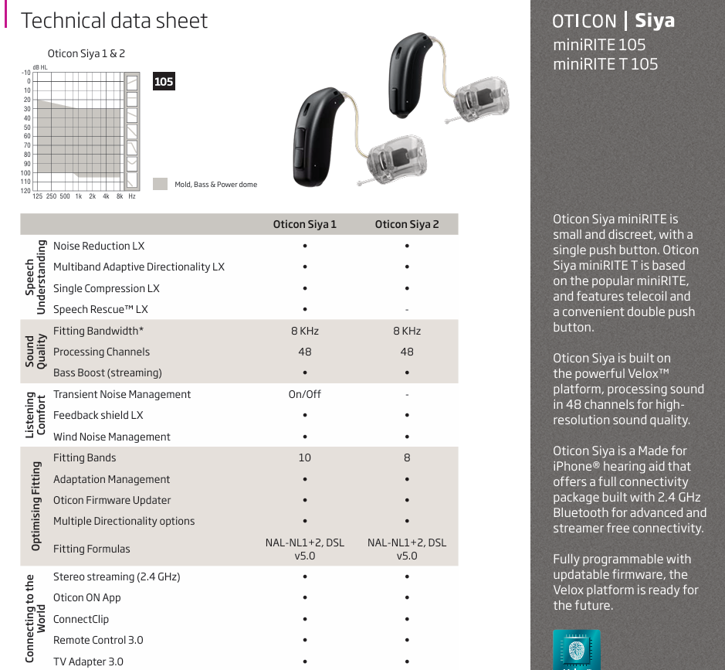

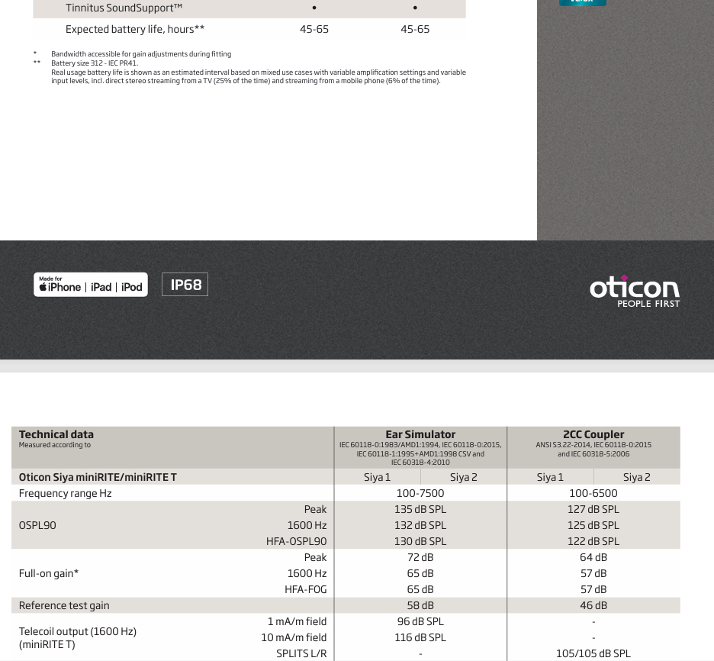

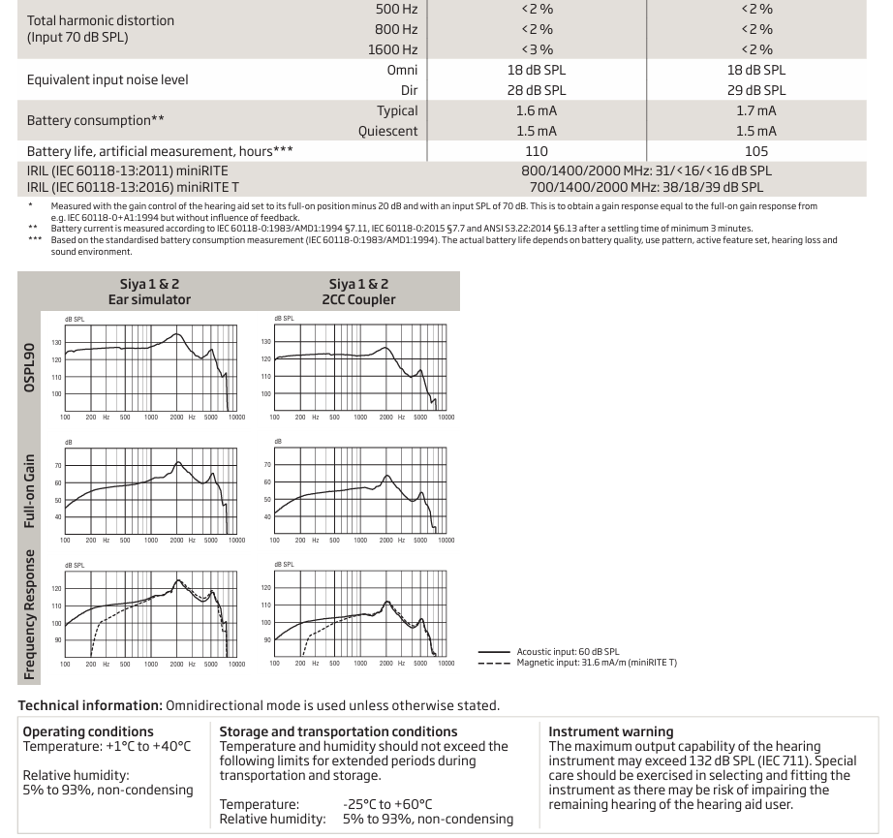

1. Fusion Software



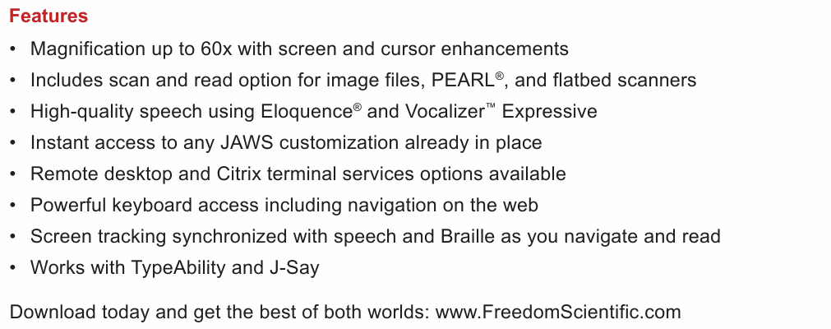

1. Dragon Software



1. Victor Reader



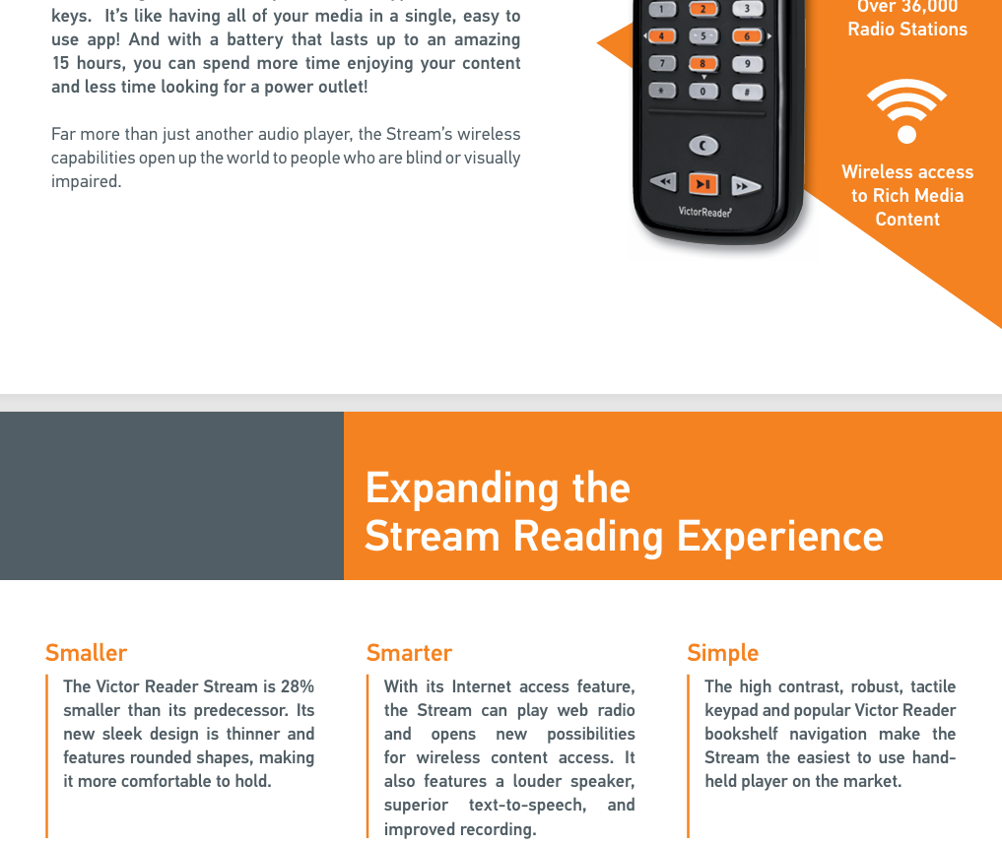



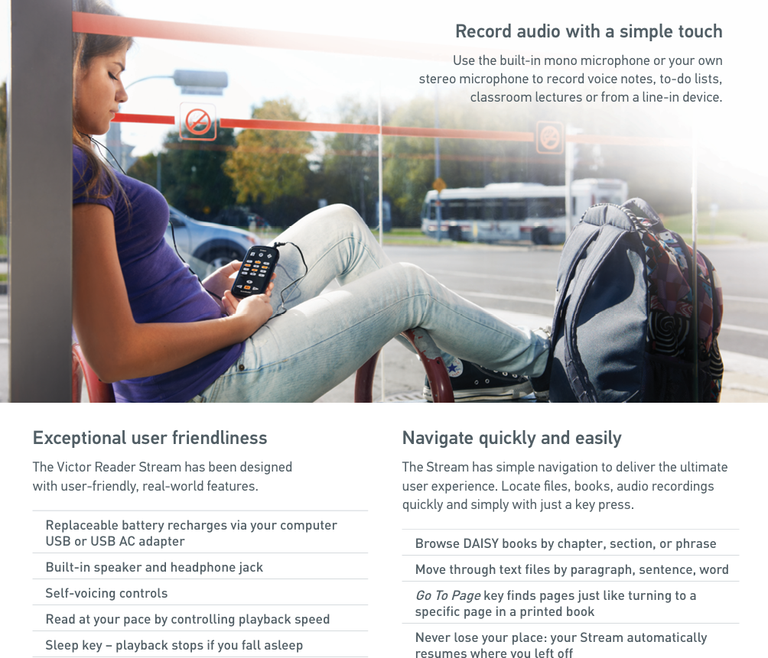

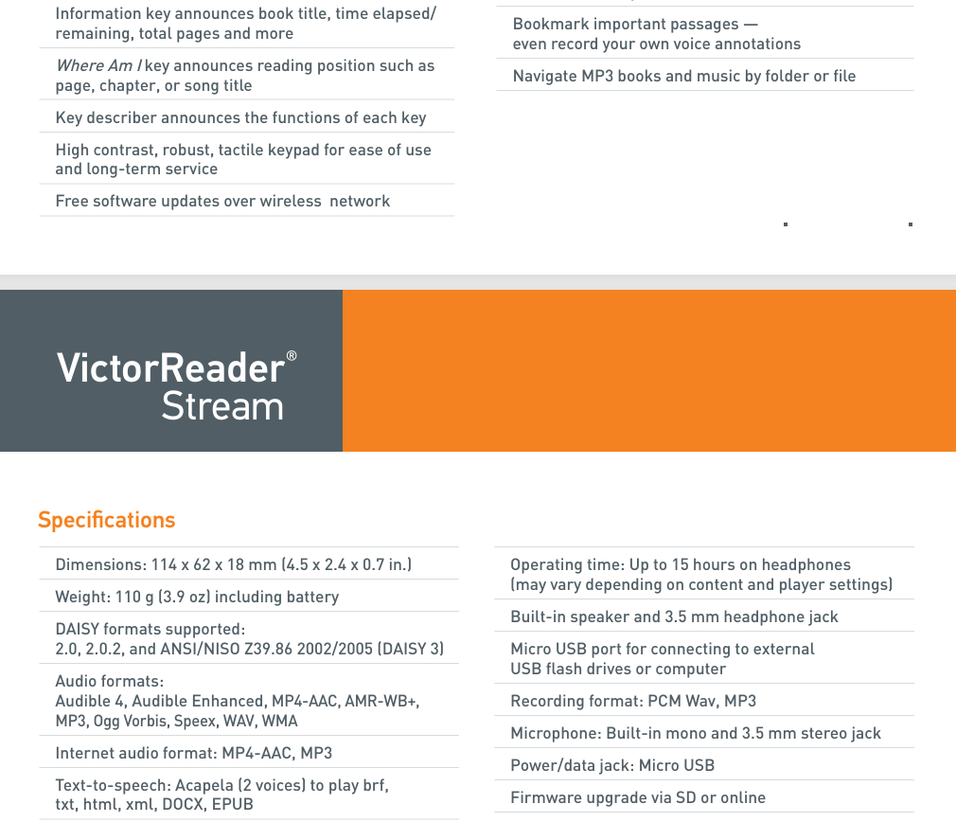

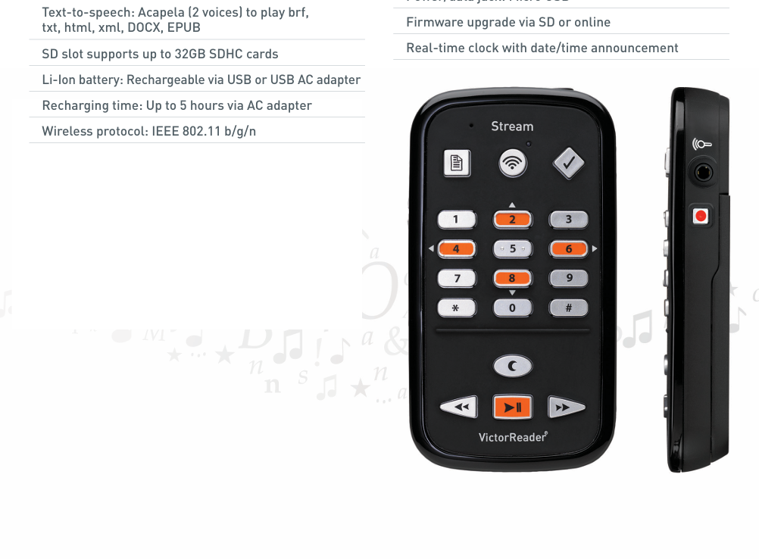

1. Focus Blue 40

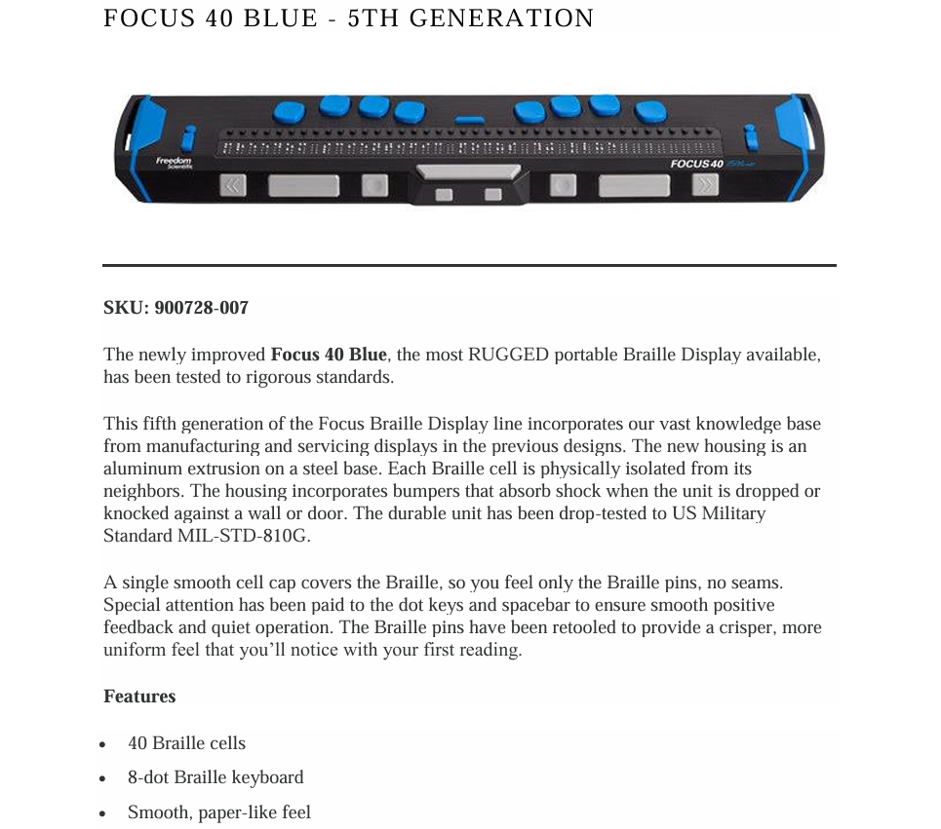

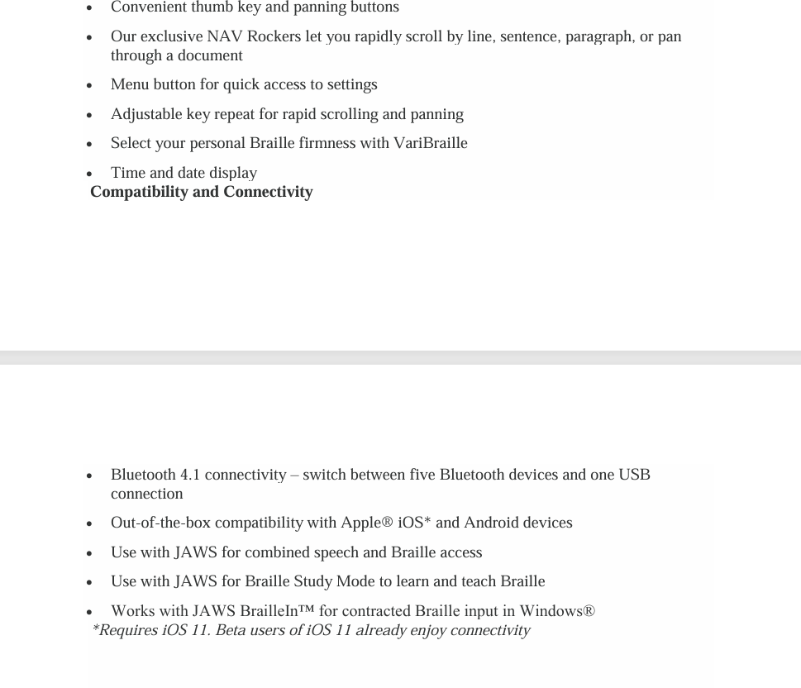



1. Audio Recorders

|  |  |
| --- | --- |
| 1. Compatible Devices | Personal Computer |
| Brand | Holyask |
| Hardware Interface | USB |
| Microphone Form Factor | Built-In |
| Format | WAV |
| Headphones Jack | 3.5 millimeters |
| Number of Batteries | 1 Lithium Ion batteries required. (included) |
| Product Dimensions | 0.5"D x 1.4"W x 3.3"H |
| Memory Storage Capacity | 32 GB |
| Item Weight | 35 Grams |

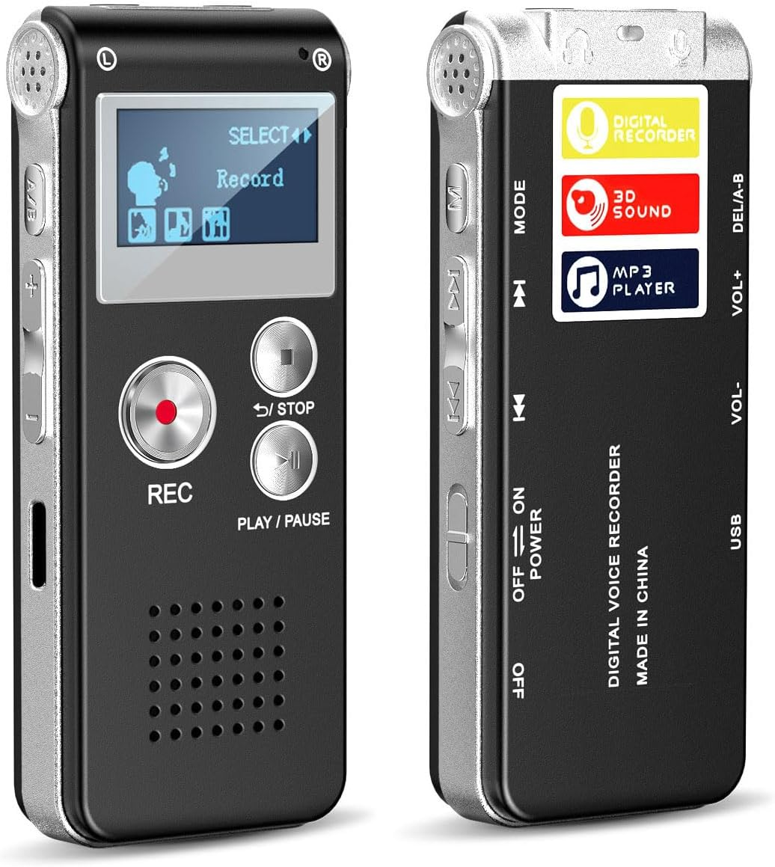

**32GB Digital Voice Recorder with Playback – USB Rechargeable Dictaphone for Lectures, Upgraded Small Tape Recorder Device, Voice Activated Recording, and HD...**